**EXPERIMENT 1**

Download and install oracle virtual Box 5.x and Vagrant 2.2.7.

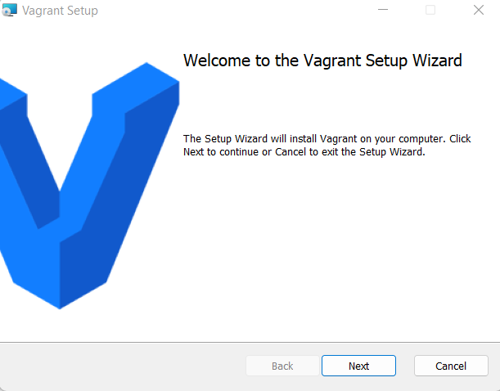

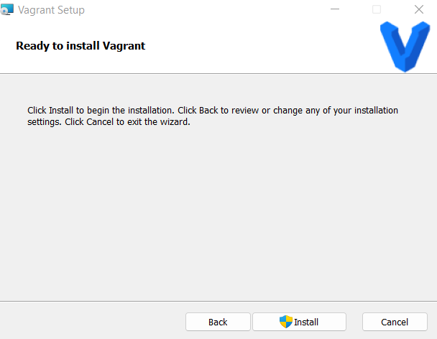

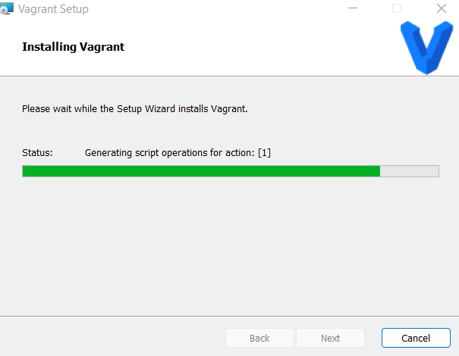

2. Check working of Vagrant using vagrant –version command

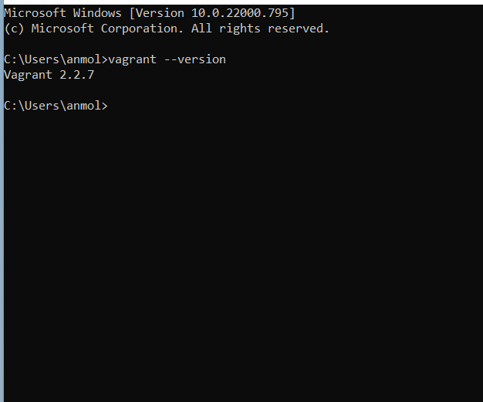

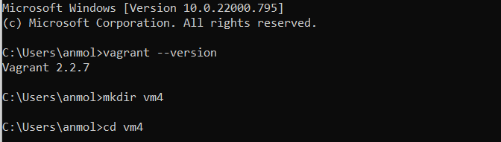

3.Create a new directory using CMD

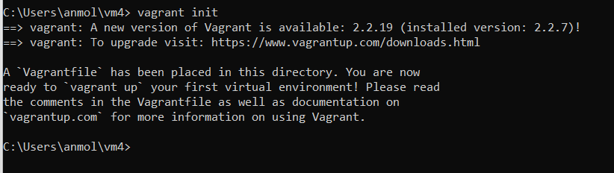

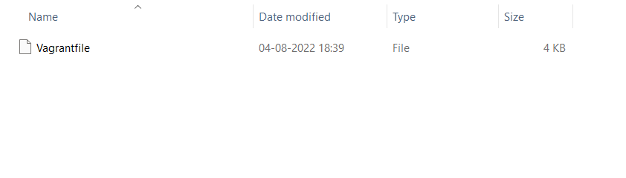6. Vagrant up command.

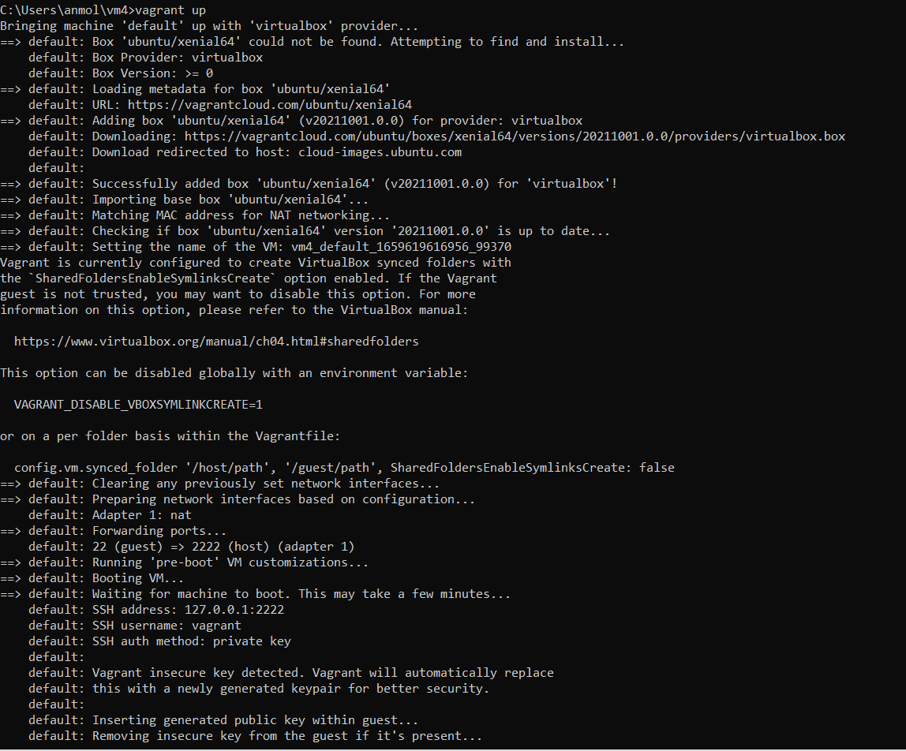

7. Run vagrant SSH command

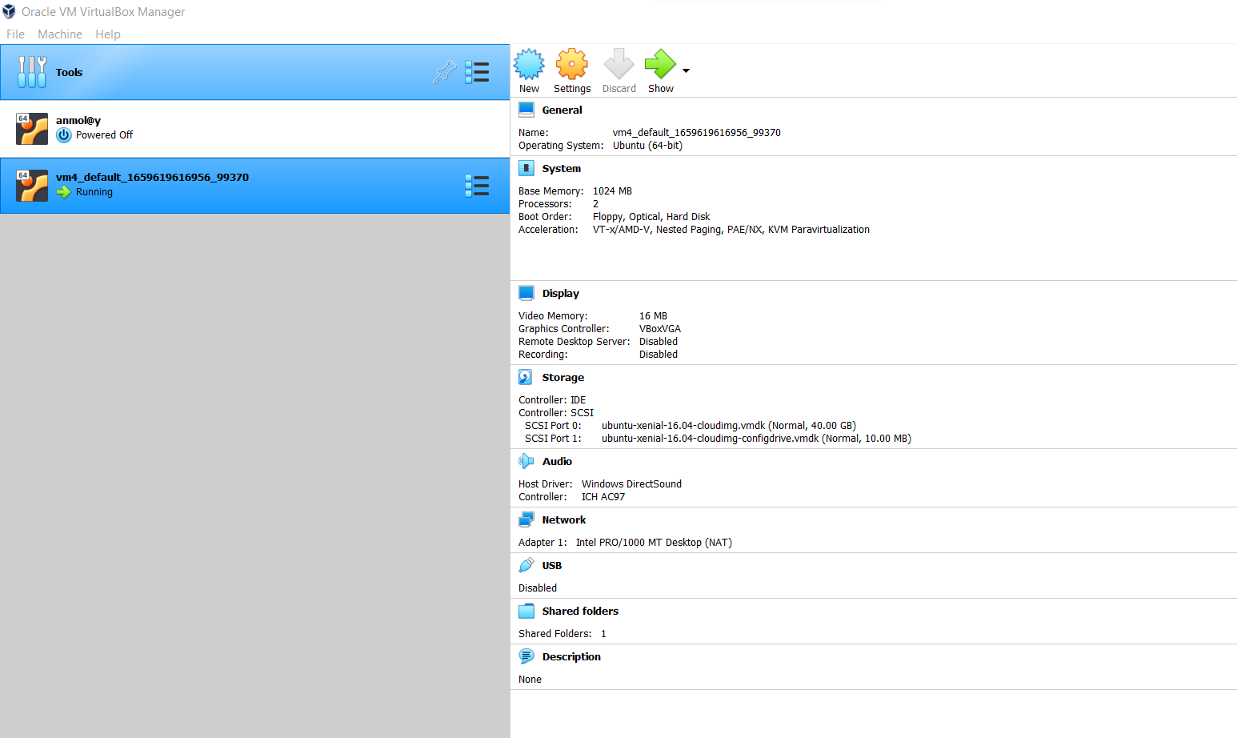

8. Run vagrant halt command

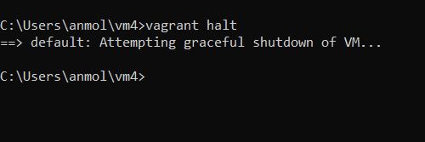

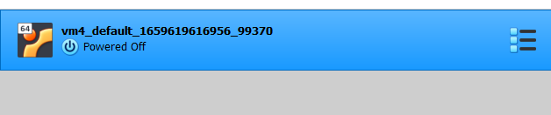

9.Run vagrant Destroy to delete VM

